Ideation Phase
Empathize & Discover

Date | 30 August 2026
Project Name | Automated Network Request Management
Maximum Marks | 4 Marks

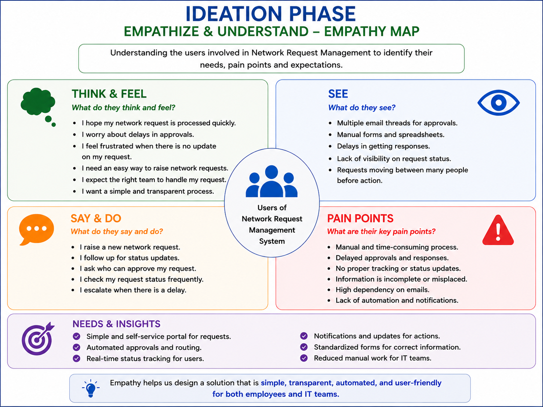

IDEATION PHASE – EMPATHIZE & UNDERSTAND
Empathy Map
This Empathy Map helps us understand the needs, expectations, frustrations, and experiences of users involved in network service requests. It focuses on common problems such as manual request processing, approval delays, incorrect request assignment, lack of request visibility, and repeated work for IT teams.

Key Insight:
Users need a simple, transparent, and automated way to submit network requests, receive approvals, track request progress, and get timely notifications. At the same time, IT teams need an efficient system to process, assign, approve, and manage network requests with less manual effort. These needs lead to the proposed Automated Network Request Management System.

